Kaihoe o Ngāti Rēhia Pre Nationals
Saturday 4th January 2023
Lake Manuwai, Waipapa
Kaihoe o Ngati Rehia Trust – Waka Ama Club
Pānui 1

EVENT SUMMARY

Kaihoe o Ngāti Rēhia are proud to present another Pre Nationals regatta at the majestic Lake Manuwai and you are all invited.
A great regatta for kaihoe and teams to strengthen our whanaungatanga, to dust off the cobwebs, to get those race plans and race strategies on point for nationals the following week.
EVENT SCHEDULE

8.00am | Registration, Waka Drop Off
9.00am | Karakia
9:15am | Race & safety briefings
9.30am | Racing Starts
2pm | Approx Race Finish
2:15pm | Closing Karakia

RACE SCHEDULE

Time | Race
9.15am | Race Briefing - all races
9.30am | Race Start ( If not earlier)
 | W6 3000m Blow Out the Cobwebs
 | W1 3000m Blow Out the Cobwebs
 | W6 500m Straights - Int, J16, J19, Opens, Masters, SMs, GMs
 | W6 250m Straight Midget Boys and Girls
 | W6 500m Turn Intermediate Boys and Girls
 | W1 500m Straights - Int, J16, J19, Opens, Masters, SMs, GMs
 | W6 1000m Turns - J16, J19, Opens, Masters, SMs, GMs
2pm | Approx finish!

RACE DAY INFORMATION

Car Parking: Parking is available in the reserve on site. Please note NO parking in the lake driveway, unless instructed by kaiāwhina.
Trailer parking: Trailer parking will be in front of the shed, as per normal.
Food: We encourage you to bring CASH to purchase kai from our kai stall, but of course you can also bring your own delicious kai too.
Toilets: Toilets are located at the far end of the driveway, by the shed past the main registration tent.
First Aid: First Aid will be available at the registration tent, via the main driveway.
Rubbish/Recycling: We encourage you to please take what you bring.
Alcohol/Smokefree: Alcohol, smoking, vaping and any other substance use is not permitted at this event, including all premises of the event.

WAKA DROP OFF & SAFETY CHECKS

Waka Drop off:
- Waka drop off will be available from 7.00am on the event day.
- Waka drop off will be down the right of the drive, by the shed.
- Trailer parking is in the same place as drop off, please be aware of your surroundings and park side by side.

Safety Checks:
- All waka will have to pass a safety check and be marked before racing. Any boats not marked
will not be permitted to race.

RACE RULES

All entrants must be familiar with the Waka Ama New Zealand race and safety rules.
Refer to the following link for more information: Waka Ama NZ Race Rules

AGE DIVISIONS & RACE EVENTS

WAKA | DISTANCE | DIVISIONS | GENDER
W6 | 3000m | J16, J19, Open, Master, Senior Master, Golden Master | Men, Women, Mixed
W1 | 3000m | J16, J19, Open, Master, Senior Master, Golden Master | Men, Women
W6 | 500m | Int, J16, J19, Open, Master, Senior Master, Golden Master | Men, Women, Mixed
W6 | 250m | Taitamariki (Midgets) | Boys, Girls, Mixed
W6 | 500m Turn | Intermediate | Boys, Girls, Mixed
W1 | 500m | Int, J16, J19, Open, Master, Senior Master, Golden Master | Men, Women
W6 | 1000m Turn | J16, J19, Open, Master, Senior Master, Golden Master | Men, Women, Mixed

FEES

PER PERSON BY AGE DIVISION (charged one fee according to age on race day)
Age Division | Cost
Taitamariki | Gold Coin
Intermediate | $5.00
J16 and Above | $10.00

ONLINE ENTRIES & PAYMENT

- Online entries are to be completed using the Waka Ama NZ online entry system. https://wakaama.co.nz/racecalendar/lookup/2298
- All entries to be completed through your club admin – contact your club admin to process your entry
- No entries on the day, no exceptions
- Entries close on 30th December 2024 11.59pm
- Rosters close on 30th December 2024 11.59pm rosters must be completed by close date, no exceptions
- Once entered, payment can be made online to:
  - Kaihoe o Ngati Rehia Trust
  - 12-3091-0219174-00
  - Use your club, team name and division as your reference

SAFETY REQUIREMENTS

- All waka must be Safety Checked
- All Tamariki 16 years and under must wear life jackets
- All Junior (J16 & J19) and Senior (Open and above) must have the following safety equipment for their races:
  - PFD - Personal Floatation Device (per person)
  - Bailers
  - Flare or cellphone in waterproof case
  - Spare Paddle - 2 for a W6, 1 for W1/2
  - Spray Skirt (W6)
  - Tow Rope (W6)
  - Leg leash (for sit on top W1)

INDIVIDUAL & TEAM WAIVERS
- Individual and Team waivers must be completed by all paddlers/teams
- All paddlers U18 must have their waiver signed by their parent/guardian
- Waivers can be sent to kaihoengatirehia@gmail.com or handed in to registration on the day
- Individual & Team waivers can be found here: https://wakaama.co.nz/racecalendar/lookup/2298

CONTACT INFORMATION

- All enquiries please email: kaihoengatirehia@gmail.com
- All urgent matters please call: Sophia Thomas 0272405490
- Facebook: https://www.facebook.com/groups/156538157714816

COURSE MAPS

Map 1: 3000m Race Course
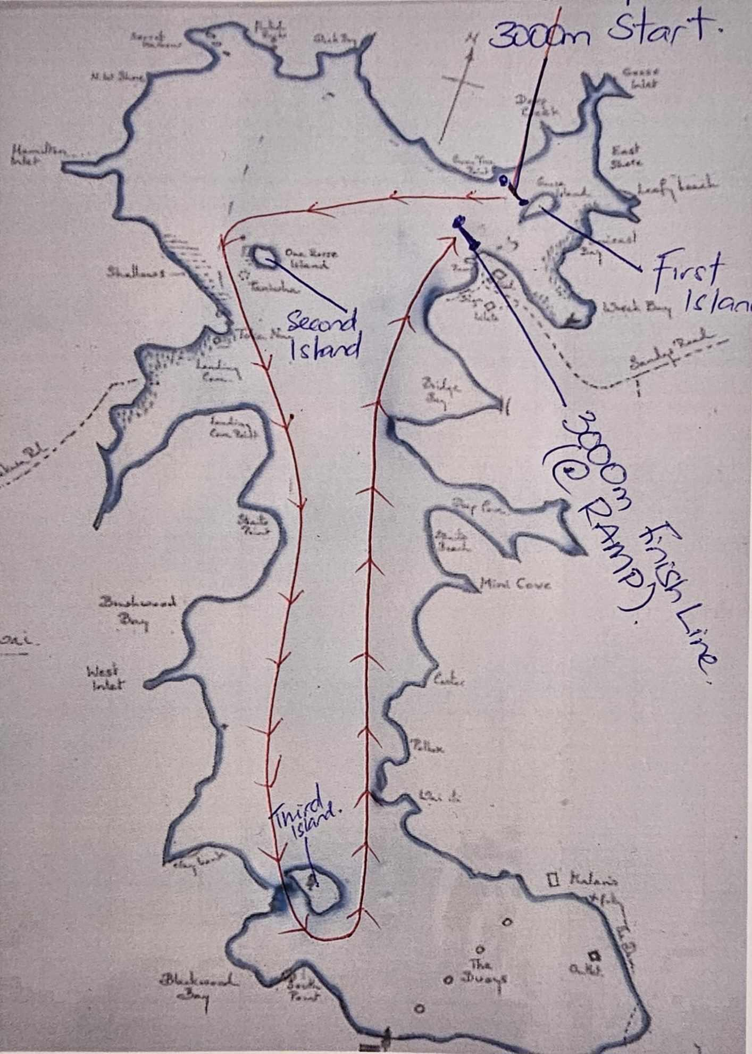

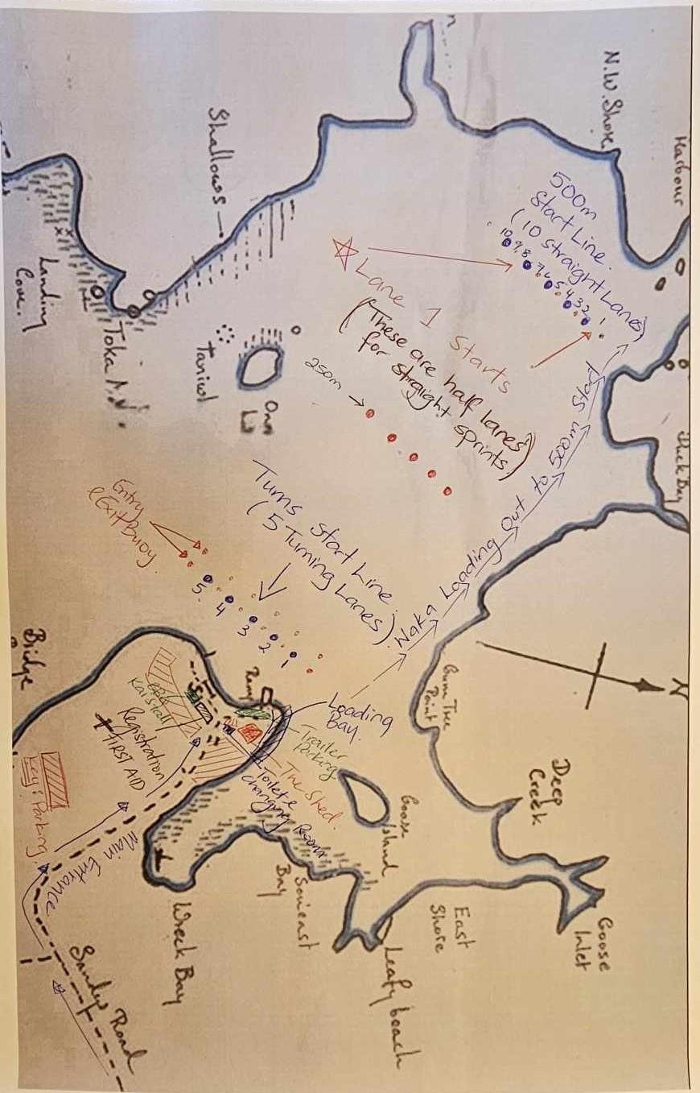
Map 2: 500m Sprint and Turns Race Course

